Images and Commentary:

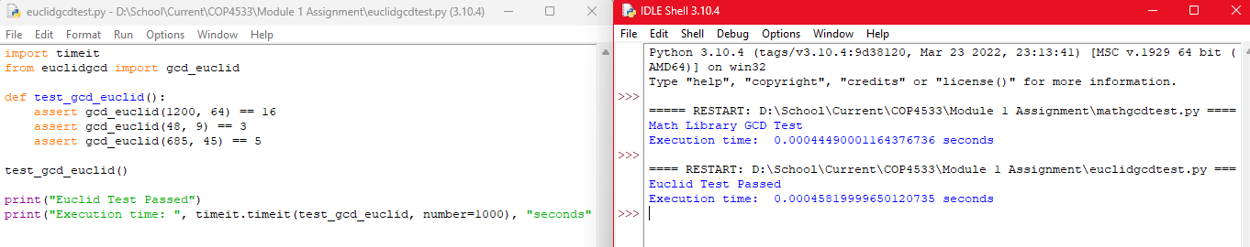

I am not sure what the assignment wants when it says to write commentary. The first image is both functions by themselves, the second image is running the testfile on mathgcd, and the third image is running the testfile on euclidgcd. I am surprised that math.gcd() returned a with a faster response.

Code as Text:

mathgcd.py:

import math

def gcd_math(a, b):

return math.gcd(a, b)

euclidgcd.py:

def gcd_euclid(a, b):

while b:

a, b = b, a % b

return a

mathgcdtest.py:

import timeit

from mathgcd import gcd_math

def test_gcd_math():

assert gcd_math(1200, 64) == 16

assert gcd_math(48, 9) == 3

assert gcd_math(685, 45) == 5

test_gcd_math()

print("Math Library GCD Test")

print("Execution time: ", timeit.timeit(test_gcd_math, number=1000), "seconds")

euclidgcdtest.py:

import timeit

from euclidgcd import gcd_euclid

def test_gcd_euclid():

assert gcd_euclid(1200, 64) == 16

assert gcd_euclid(48, 9) == 3

assert gcd_euclid(685, 45) == 5

test_gcd_euclid()

print("Euclid Test Passed")

print("Execution time: ", timeit.timeit(test_gcd_euclid, number=1000), "seconds")